Abu Dhabi’s Macro & Sectoral Economic Indicators
Gross Domestic Production (GDP):
According to the latest estimates of the Statistics Center − Abu Dhabi (SCAD), the Gross Domestic Production (GDP) of Abu Dhabi (at current prices) amounted approximately to AED 960.1 billion in 2014, compared to AED 931.8 billion in 2013. The positive momentum of the non-oil sector’s activities contributed significantly to the promotion of Abu Dhabi’s economic performance during 2014, as the growth rate of non-oil gross domestic production reached approximately 12% in the aforementioned year when compared to 2013. This robust economic growth was achieved by the non-oil sectors, as the Real Estate Sector was leading over all of the other sectors with an annual growth rate of 22.3%, which were followed by the Financial and Insurance Sectors with approximately 19.7%, and the Processing Industries Sector with approximately 12.6%, then the other sectors with variant growth rates. The Non-oil sectors’ growth was concurrent with the drop in global oil prices in the second half of 2014 that greatly affected the performance of the oil sector.
Table no. (1)
Abu Dhabi’s Gross Domestic Production (GDP) at Current Prices & Growth Rates (2014)
Component | Value  (AED Billion) | Annual Growth Rate (%)
Gross domestic production (GDP) | 960.1 | 3
Gross domestic production (GDP) (for non-oil sectors) | 471.1 | 12
Source: Statistics Center − Abu Dhabi (SCAD)
The relative contribution of the non-oil sectors to the gross domestic production (GDP) of Abu Dhabi increased significantly in 2014 by reaching approximately 49.1% of total output when compared to approximately 45.1% in 2013.
Since the beginning of 2015, the global economy witnessed several developments, such as continuous fluctuations in the international oil prices, as the average price of Brent crude oil was USD 53.92 per barrel in the first quarter of 2015; However, oil prices rose slightly reaching the price of USD 61.69 in the second quarter of 2015, then dropping down to USD 50.23 in the third quarter of 2015.
The performance of the emerging market economies and developing countries, including exporters of primary commodities, slowed down due to the slowdown in the performance of the major economies, especially China, in addition to the weak performance of some major economies included in the group of advanced economies, such as Japan whose economy entered a recession by the end of the third quarter of 2015.
Figure no. (1)
Relative Contribution of Oil and Non-Oil Sectors to the Structure of Gross Domestic Production (GDP) at Current Prices
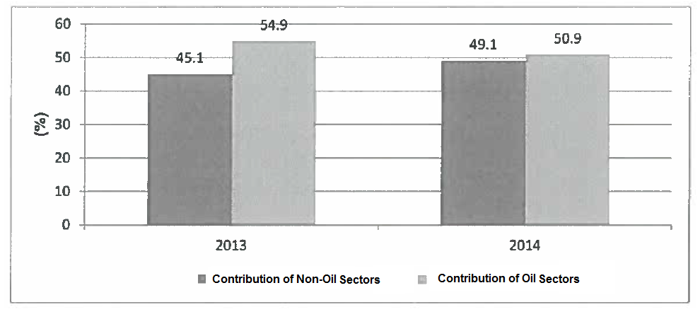

Source: Statistics Center − Abu Dhabi (SCAD)- Statistical Yearbook of Abu Dhabi for 2015.
All global economic developments, along with some domestic developments, have greatly affected Abu Dhabi’s economy in the third quarter of 2015, as per the results of Abu Dhabi’s development indicators showing lower optimism among consumers and businessmen in the aforementioned quarter compared to previous periods.
However, the latest available indicators show good performance rates for a number of non-oil sectors, such as the sectors of tourism, real estate, banks and foreign trade, within the first nine months of 2015, as described hereinafter.
The aforementioned indicators show that Abu Dhabi has the ability, considering the available economic components including its economic and social stability, good financial conditions, and business competitiveness, to turn all challenges of global developments into opportunities, and to exert more effort to promote economic diversity to achieve the goals of the Abu Dhabi Economic Vision 2030.
Some Sectoral Performance Indicators:
The economic performance of Abu Dhabi has, to some extent, been affected by the low levels of optimism among individuals and consumers, on one hand, and businessmen, on the other hand, as to their business conditions, in particular, and the economic conditions, in general. Such impressions have adversely affected the performance of a number of the economic sectors present in Abu Dhabi.
Such impressions have significantly affected overall demand. The data from the Central Bank indicate a recession of liquidity in the financial markets in the third quarter of 2015, as money supply (N2) declined at a rate of 1.1% in the third quarter of 2015, compared to 0.6% in the same quarter in 2014, while inflation rates were rising by the beginning of December 2014.
Tourism:
In the Tourism Sector, the latest data from the Abu Dhabi Tourism and Culture Authority showed improvement in the performance of the Tourism Sector during the period from January to August in 2015 compared to the same period of months in 2014, as the number of overnight visitors in Abu Dhabi’s hotels rose at a rate of approximately 20%, totaling approximately 2.7 million tourists.
The latest data from the Abu Dhabi Tourism and Culture Authority showed an increase in the number of hotel nights at a rate of 14%, totaling 7.6 million hotel nights, while the rate of overnight stays decreased at a rate of approximately 5% compared to the period from January to August in 2014. The occupancy rate rose in the period from January to August in 2015 at a rate of 1%, on an average basis, compared to the same period of months in 2014. The total revenues of the hotels have increased at a rate of 9%.
In August 2015, the number of hotel guests rose at a rate of approximately 16% compared to August 2014, as the number of guests increased approximately to 357,430 total guests. The number of hotel nights also rose at a rate of approximately 15%, reaching approximately 1,011,285 nights total, leading to an increase in the total revenues of the hotels at a rate of approximately 4% totaling approximately AED 417 million in August of 2015. The occupancy rate in the hotels reached approximately 71% in the aforementioned month with a slight increase of 1% when compared to August 2014.

